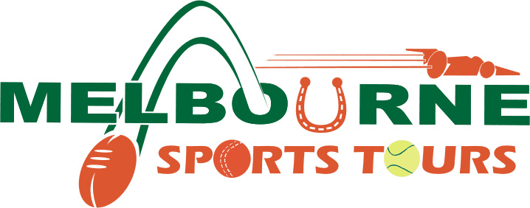

Offering interactive guided tours of Melbourne and its sporting culture since 2004

January 2019 marks 15 years since Kirsty & Anthony Grace launched Melbourne Sports Tours.
As the Sporting Capital’s only dedicated Sport Sightseeing Tour Operator, we are proud to have been delivering high quality product over such an extended period.

Recently we have observed a change in our visitor profile, particularly the desire for bespoke sightseeing and experiences. We are consequently undertaking a significant change to our business structure.

From April 1st 2019 we will reduce our FIT offerings and our focus will move to Private and Group Experiences.
We will continue to offer limited Public Tours on the first Friday of each month and selected dates (see below), mainly around Melbourne’s Major Events.
Our tried and true itineraries will remain but we will also release a new range of Private Tour itineraries.

Melbourne Sports Tours offer:
- Small group tours hosted by local Melburnians offering an insider’s guide to Melbourne
- Private bespoke itineraries exclusively designed to suit your individual, small or large group needs
- Student tours – walking and bus tours
- Active options to Play Tennis, AFL Football Coaching Clinics
- Corporate and Incentive team building and leisure days
- Combined ½ day work training and ½ day social activities
- Selected Public Tour departures, mainly during Melbourne event periods. See website for public tour dates.

SPORTS LOVERS TOURS OF MELBOURNE
Explore behind the scenes of the city which hosts Australia’s favourite sporting events. Half and full day options. Tour behind the scenes of MCG &/or Rod Laver Arena. Discover the interactive National Sports Museum. Visit Flemington Racecourse & Albert Park F1 Track. Options for a birds-eye view from Eureka SkyDeck, Stomping Ground Brewery Tour & Tastings, Play Tennis on Australian Open Showcourts, various meal options… More Here

AUSSIE RULES FOOTBALL with a local host
Your local host will explain all the rules, bumps and bruises of our unique game during this private tour experience enjoying the best seats in the house. Footy Food, Competitions, Club Scarf, Club Songs, Rules Sheet, Football Souvenir Record included at The MCG or Marvel Stadium. Private Tour for 1 to 150 people. Ask about skills coaching session; learn to handball, kick, mark. Hosted Corporate boxes options. More Here

HORSES, WINE & BEER / LEGENDS & CHAMPIONS TOUR
Meet famous racehorses and enjoy morning tea in the historic homestead at ‘Living Legends’; a Parks Victoria retirement village for our favourite retired Champions. Enjoy lunch and wine tastings at Gisborne Peak and beer tastings at the Holgate Brewery in Woodend. Options to combine with the Champions racing Museum at the MCG, Flemington racecourse Visitors Centre and Private Tour upgrade options to visit Horse Stud Sun Stud More Here

FOOD & BEVERAGE GOURMET TRAILS – focussing on Australian Native Ingredients
Melbourne, Yarra Valley & Mornington Peninsula itineraries to suit your requirements.

COMBINE ½ Day Training with ½ Day Team Build Experience

Page 1 of 2
PUBLIC TOUR DATES
Additional dates will be loading into our Reservation System/Rezdy

2019 Public Melbourne Sports Lover Tour Dates
Friday April 5th
Wed April 24th – Anzac Eve
Friday May 3rd
Monday May 6th
Thursday May 9th – Good Beer Week
Friday June 7th
Tuesday June 11th – After Queens Birthday Long Weekend
Friday July 5th
Friday August 2nd
Friday August 30th – Melbourne Day
Friday September 6th
Friday October 4th
Friday October 25th – Before Cox Plate
Friday November 1st
Wednesday November 6th
Friday November 8th
Friday December 6th

Updated regularly at www.melbournesportstours.com.au/citysportstours

2019 Public Horses, Wine & Beer & Legends & Champions Tour Dates
Friday October 25th (LC, HWB, SL)
Friday November 1st (HWB, SL)
Sunday November 3rd (HWB, LC)
Monday November 4th (LC)
Wednesday November 6th (HWB, SL)
Friday November 8th (HWB, LC, SL)
Sunday November 10th (HWB)

Updated regularly at www.melbournesportstours.com.au/melbourne-day-tours-horse-wine-beer-tour

sales@melbournesportstours.com.au www.melbournesportstours.com.au
OFFICE: (+61) 03 8802 4547

Melbourne Sports Tours Operations Manager: Anthony Grace – 0411 252 700
Melbourne Sports Tours Sales & Marketing: Kirsty Grace – 0403 15 15 50

Melbourne Sports Tours @MelbSportsTours

Did you know that Melbourne is The Sport Capital of the World…Of The Decade?!

Page 2 of 2

